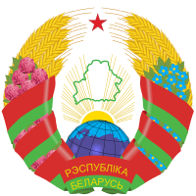
 | Национальное Собрание Республики Беларусь | 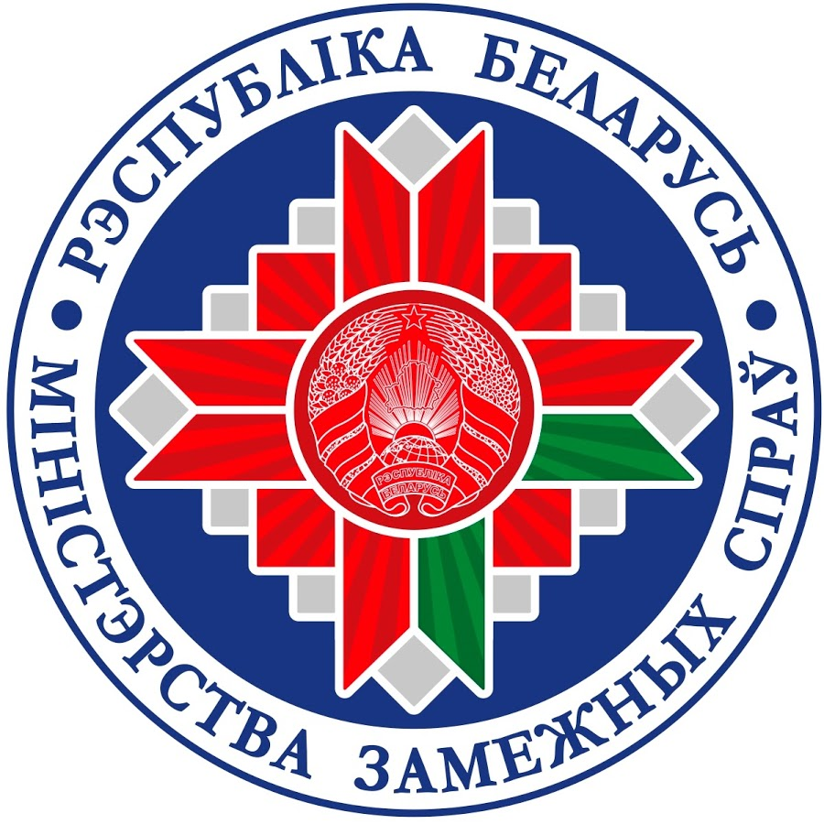 | 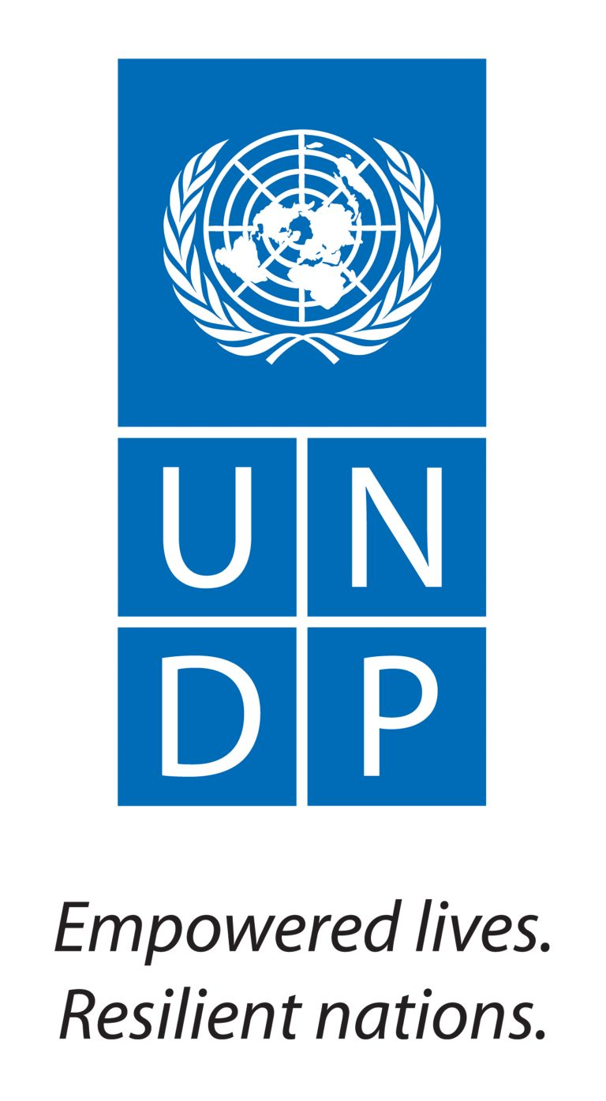

Sustainable Development Goals –
implementation at the national and regional levels
Seminar
NOVEMBER 15, 2017 • Hotel Beijing,
Minsk, Krasnoarmeyskaya, 36, 1 floor

Moderator: Ms. Larisa Belskaya,

Head of the Main Directorate

for Multilateral Diplomacy

of the Ministry of Foreign Affairs

of the Republic of Belarus
10.00-10.30 | REGISTRATION (tea, coffee)  Press conference

10.30-11.00

Opening, welcome words

Presentation of the book “Starting conditions of Belarus in achievement of SDGs»

Ms. MARIANNA SHCHETKINA,

National Coordinator on Implementation of Sustainable Development Goals - Deputy Chairperson of the Council of the Republic of the National Assembly of the Republic of Belarus

МR. SANAKA SAMARASINHA,

UN Resident Coordinator /UNDP Resident Representative

Presentation of the book “Starting conditions of Belarus in achieving SDGs”

11.00-12.30

Session 1. Sustainable Development Goals - implementation at the international and national level

11.00-11.15 | Creation of a national system of indicators for the monitoring of the Sustainable Development Goals  Ms. Inna Medvedeva, Chairperson of the National Statistical Committee
11.15-11.30 | Implementation of the Sustainable Development Goals in the Economic Area  Mr. Alexander Chervyakov, Deputy Minister of Economy
11.30-11.45 | Implementation of the Sustainable Development Goals in the Environmental Area  Ms. Iya Malkina, Deputy Minister of Natural Resources and Environmental Protection
11.45-12.00 | Implementation of the Sustainable Development Goals in the Social Sphere  Mr. Valeriy Kovalkov, Deputy Minister of Labor and Social Protection
12.00-12.15 | The main approaches to the creation of a national strategy for sustainable socio-economic development of the Republic of Belarus in the context of the implementation of the Sustainable Development Goals  Ms. Lyudmila Borovik, First Deputy Director of the National Economics Research Institute of the Ministry of Economy
12.15-13.00 | COFFEE BREAK

13.00–13.45

Session 2. Sustainable development goals - implementation at the regional level

13.10-13.15 | The major principles of SDGs localization  Ms. Oksana Remiga, Programme Specialist, Local Governance and Decentralization, DA at Istanbul Regional Hub, UNDP
13.15-13.30 | Implementation of the Sustainable Development Goals at the regional level  Ms. Natalya Berchenko, Deputy Director of the Economics Research Institute of the Ministry of Economy
13.30-13.45 | Development and implementation of local strategies for sustainable development (Belarusian and foreign experience)  Mr. Aleg Sivagrakov, expert on sustainable development, associate professor of the International Sakharov Environmental Institute of Belarusian State University
13.45-14.00 | Successful practices of implementing the principles of sustainable development at local and regional levels: from the experience of the Belarus Support Program  Mr. Dmitry Karpievich, Coordinator of the Belarus Support Program of the Federal Government of Germany (for Sustainable Development)

14.00-14.50

Session 3. Partnership - a key factor in achieving the goals of sustainable development

14.00-14.20 | Education for Sustainable Development - a condition for achieving the Sustainable Development Goals  Ms. Sofia Savelova, Head of the Coordination Center “Education for Sustainable Development” of the Belarusian State Pedagogical University named after Maxim Tank;  Mr. Anatoly Muravyov, Executive Director of the Association "Education for Sustainable Development", Director of the Minsk Gymnasium №19.
14.20-14.35 | Partnership of public organisations and the state to achieve the Sustainable Development Goals  Ms. Svetlana Zinkevich, Director of the educational institution "Office of European Expertise and Communications"
14.35-14.50 | Partnership of business and the state to achieve the Sustainable Development Goals  Mr. Alexander Skrabovsky, Head of the Office of the UN Global Compact Network in Belarus

14.50-15.10

Discussion. Questions and answers.

Closing of the seminar

Ms. MARIANNA SHCHETKINA,

National Coordinator on Implementation of Sustainable Development Goals - Deputy Chairperson of the Council of the Republic of the National Assembly of the Republic of Belarus UNDP Representative in Belarus

15.10-16.00 | LUNCH

